

**INTERNATIONAL SCHOOL**

**COURSE PROJECT 1**

**CMU-CS 246 HIS**

**DEFINDED PROCESS DOCUMENT**

Version: 1.1

**CALCULATION SYSTEM– CS**

**Mentor: Nguyen Dang Quang Huy**

***Team Member*:**

Pham Ngoc Trung

Mai Hoang Tung

Phan Quang Trung

Nguyen Quang Thong

Tran Quoc Hoang

**Approved by Nguyen Dang Quang Huy**

**Project Plan Review Panel Representative:**

Name Signature Date

**Capstone Project 1- Mentor:**

Name Signature Date

Da Nang, 25/2024

**PROJECT INFORMATION**

|  |  |
| --- | --- |
| **Project Acronym** | CS |
| **Project Title** | CALCULATOR SYSTEM | | | |
| **Start Date** | 25 – Jan – 2024 | **End Date** | 31 – Jan – 2024 | |
| **Lead Institution** | International School, Duy Tan University | | | |
| **Team Member** | **Name** | **Email** | | **Phone** |
| 28214305594 | Pham Ngoc Trung | phamngoctrungqb@gmail.com | | 0914223472 |
| 28211105451 | Nguyen Quang Thong | dn7110994@gmail.com | | 0775506786 |
| 28219020521 | Tran Quoc Hoang | hoanglucky321@gmail.com | | 0981553208 |
| 28214300656 | Mai Hoang Tung | tunghoang1707@gmail.com | | 0947987858 |
| 28211148230 | Phan Quang Trung | phanquangtrung30042004@gmail.com | | 0708110429 |

**PROJECT PLAN DOCUMENT**

|  |  |  |  |
| --- | --- | --- | --- |
| **Document Title** | Project Plan Document | | |
| **Author(s)** | CMU-CS 246 HIS Team 3 | | |
| **Date** | Sep 25th, 2024 | **File name:** | C1SE.28_CS_ProjectPlan_v1.1.docx |
| **URL** | https://drive.google.com/drive/folders/1VBFtGWBCnRpGMqdGtfbFpeBkVWMBZLLa?fbclid=IwAR1yayEYbziiTyqEZzhwuKG9GyvX8ZI8rmHJ_P-HtsoFvXtxV--5uHZpb4c | | |
| **Access** | Project and CMU Program | | |

**SIGNATURE**

**Document Approvals:** The following signatures are required for approval of this document.

|  |  |  |  |
| --- | --- | --- | --- |
| **Mentor** | Nguyen Dang Quang Huy | **Signature:** |  |
| **Date:** |  |
| **Scrum master** | Nguyen Quang Thong | **Signature:** |  |
| **Date:** |  |
| **ProDuct**  **Owner** | Nguyen Dang Quang Huy | **Signature:** |  |
| **Date:** |  |
| **Team member(s)** | Pham Ngoc Trung | **Signature:** |  |
| **Date:** |  |
| Hoang Tung, Quoc Hoang, Quang Trung | **Signature:** |  |
| **Date:** |  |

**REVISION HISTORY**

|  |  |  |  |
| --- | --- | --- | --- |
| **Version** | **Person(s)** | **Date** | **Description** |
| **1.0** | Pham Ngoc Trung | Jan 25th, 2024 | Draf |

**TABLE OF CONTENTS**

1. PROJECT DESCRIPTION 5

2. PROJECT DEVELOPMENT APPROACH 5

2.1. TECHNICAL PROCESS 5

2.1.1. REASON FOR SELECTING 5

2..1.2 WATERFALL MODEL 6

2.1.3. WATERFALL PROCESS 7

**Table**

**Table: Project Description........................................................................................5**

**Figuare**

**Figure: Scrum master...................................................................................................7**

# 1. PROJECT DESCRIPTION

|  |  |  |  |
| --- | --- | --- | --- |
| **Project code** | CS | **Contract type** | Internal Project |
| **Customer** | N/A | **End-user** | User |
| **Project type** | Internal | **Project Manager** | Nguyen Quang Thong |
| **Project category** | Calculater System | **Business Domain** | AI |
| **Application type** | Web Applcation |  |  |

# 2. PROJECT DEVELOPMENT APPROACH

## 2.1. TECHNICAL PROCESS

We use the Waterfall method in our projects, in addition to using software tools to manage work and assign tasks to team members such as Code, testing. And to meet project requirements, we use Java language on Netbeans tool to develop database interface.

## 2.1.1. REASON FOR SELECTING

In the Waterfall model, the development team approaches the project in a linear sequence, from requirements definition to final implementation sequentially. The team doesn't try to develop all the features at once; instead, they focus on specifying a large set of features for each phase of the project.

With this approach, the team can spend more time perfecting each feature before moving on to the next. Asking team members to complete a large amount of work in a measurable way helps them stay focused and motivated. However, for a small and inexperienced team like ours, many problems can arise during development.

The Waterfall model requires high precision and management skills, which can become a challenge for our team. Having team members complete small, measurable amounts of work helps keep them focused and motivated. While our team is a small team with little experience in project development. Therefore, we cannot avoid problems that arise in the software development stages, and requirements can be changed to be more suitable. The traditional model that requires managerial skills and high accuracy, will not suit our team. Applying the Agile Scrum model will help us to solve these problems, bring a lot of experience and best performance for project development.

## 2..1.2 WATERFALL MODEL

The Waterfall method is a linear sequential software development model, with each subsequent phase starting only after the previous phase has been completed.

• The main goal of Waterfall is to ensure that development steps are carried out in the correct order and not to start a new phase until the current phase is complete.

• Project requirements are clearly defined from the beginning, and then design, implementation, testing and finally product deployment proceed.

• Waterfall places a heavy emphasis on scheduling and progress management, with strict quality control at each stage of the project.

## 2.1.3. WATERFALL PROCESS

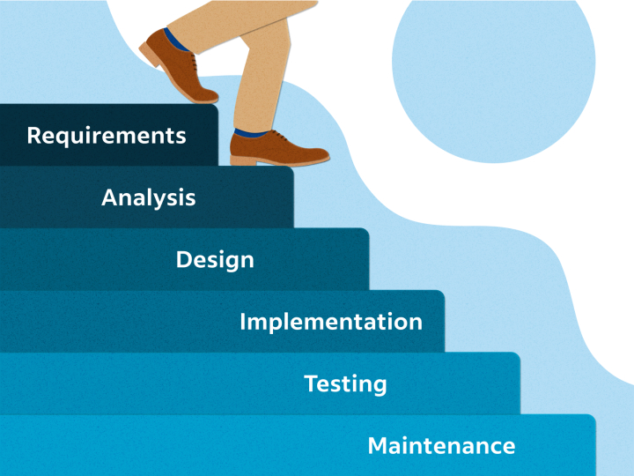

**Figure:** Waterfall

* The waterfall process has a clear structure that makes it easy to manage and understand the project development process.
* Each phase in Waterfall has well-defined testing steps, from requirements to implementation.
* Each phase ends with the creation of key documents such as design sheets, source code, and test documentation.
* The linear process makes decisions easier because information and project progress are closely tracked.
* Waterfall can be suitable for project management and development.
* Waterfall is suitable for projects that have a clear design and do not require constant adjustments during the development process.

**3. REFERENCES**

1. <https://artoftesting.com/waterfall-model>
2. https://www.wrike.com/project-management-guide/faq/what-is-waterfall-project-management/
3. <https://www.revgenpartners.com/insight-posts/when-does-waterfall-project-management-make-sense/>